**Assignment Data Science 3**

**Structure of database**

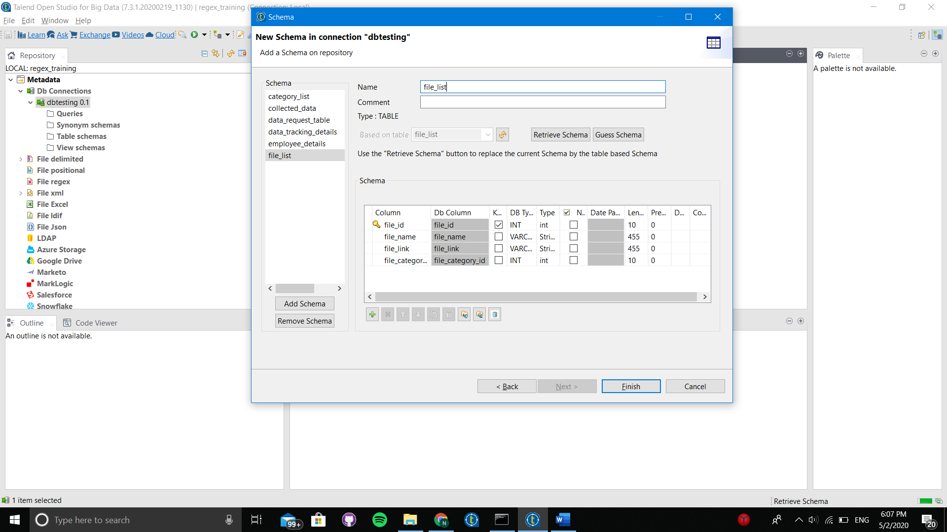

**1. Make a join of two tables using sql builder.**

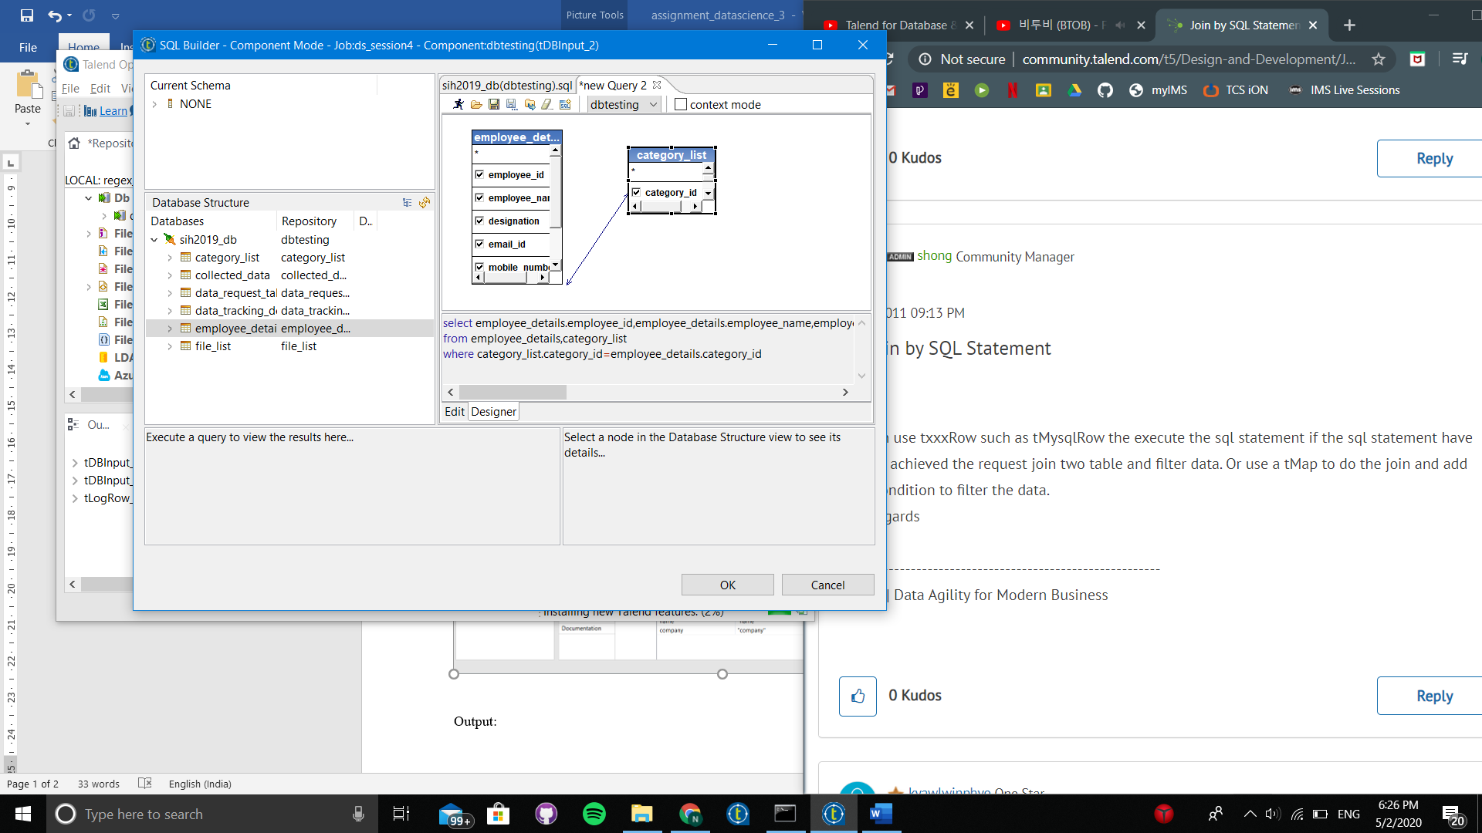

Through query:

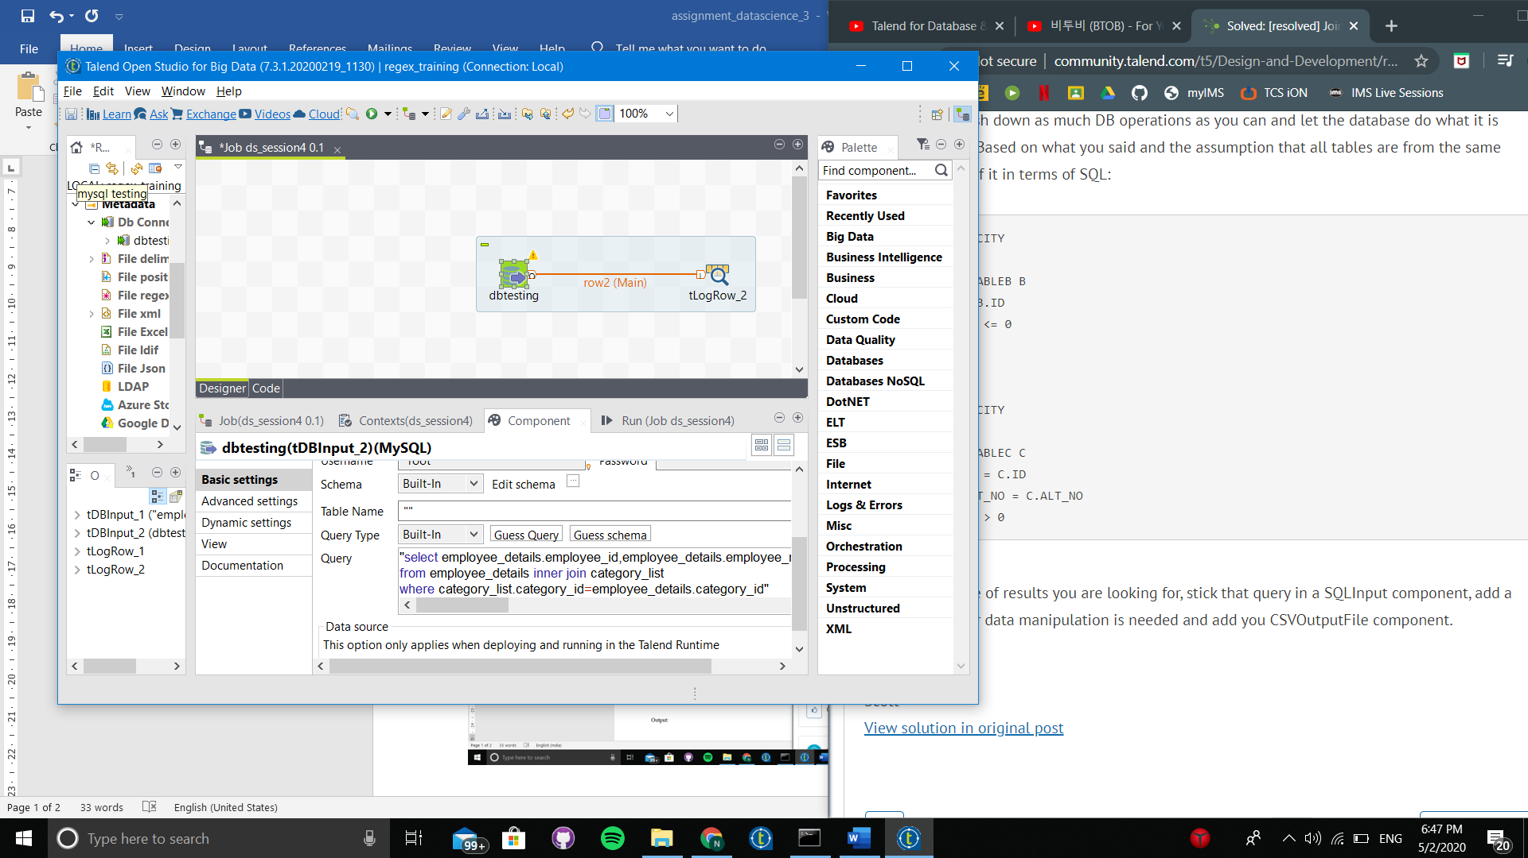

Output: